Project Design Phase-II
Data Flow Diagram & User Stories

Date | 03 October 2022
Team ID | PNT2022TMID35794
Project Name | Project – Smart solution for railways
Maximum Marks | 4 Marks

Data Flow Diagrams:
A Data Flow Diagram (DFD) is a traditional visual representation of the information flows within a system. A neat and clear DFD can depict the right amount of the system requirement graphically. It shows how data enters and leaves the system, what changes the information, and where data is stored.

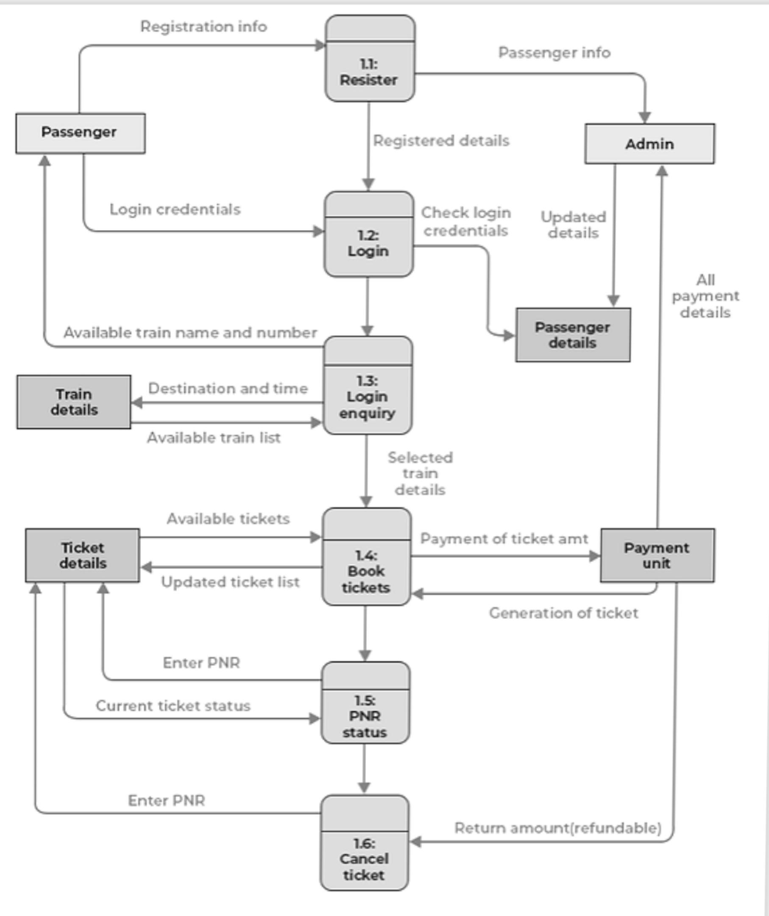

User Stories
Use the below template to list all the user stories for the product.
User Type | Functional Requirement (Epic) | User Story Number | User Story / Task | Acceptance criteria | Priority | Release
Customer (Mobile user) | Registration | USN-1 | As a user, I can register for the application by entering my email, password, and confirming my password. | I can access my account / dashboard | High | Sprint-1
 |  | USN-2 | As a user, I will receive confirmation email once I have registered for the application | I can receive confirmation email & click confirm | High | Sprint-1
 |  | USN-3 | As a user, I can register for the application using my mobile number and confirm through OTP received | I can register & access the dashboard with mobile number | Medium | Sprint-1
 |  | USN-4 | As a user, I can register for the application through Gmail | I can register & access the dashboard using mail credentials | Medium | Sprint-1
 | Login | USN-5 | As a user, I can log into the application by entering email & password | I can login using my email details | High | Sprint-2
 | Dashboard | USN-6 | As a user, I can navigate through the dashboard to get the details of seat availability and booking after logging in and entering the desired location and date | I can search for tickets based on availability to desired places on desired dates | High | Sprint-1
 |  | USN-7 | As a user, I can fill in my details and upload my ID proof and book ticket by online transaction | I can book the tickets by entering details and paying | High | Sprint-1
 |  | USN-8 | As a user, I can get the QR code for the payment and ticket booked | I can see the QR code storing the details of booking | Medium | Sprint-1
Customer (Web user) | Registration | USN-1 | As a user, I can register for the application by entering my email, password, and confirming my password | I can access my account / dashboard | High | Sprint-1
 |  | USN-2 | As a user, I will receive confirmation email once I have registered for the application | I can receive confirmation email & click confirm | High | Sprint-1
 |  | USN-3 | As a user, I can register for the application using my mobile number and confirm through OTP received | I can register & access the dashboard using mail credentials | Medium | Sprint-1
 |  | USN-4 | As a user, I can register for the application through Gmail | I can register & access the dashboard using mail credentials | Medium | Sprint-1
 | Login | USN-5 | As a user, I can log into the application by entering email & password | I can login using my email details | High | Sprint-2
 | Dashboard | USN-6 | As a user, I can navigate through the dashboard to get the details of seat availability and booking after logging in and entering the desired location and date | I can search for tickets based on availability to desired places on desired dates | High | Sprint-1
 |  | USN-7 | As a user, I can fill in my details and upload my ID proof and book ticket by online transaction | I can book the tickets by entering details and paying | High | Sprint-1
 |  | USN-8 | As a user, I can get the QR code for the payment and ticket booked | I can see the QR code storing the details of booking | Medium | Sprint-1
Customer Care Executive | Dashboard | USN-1 | As a CCE, I can help the user in resolving issues regarding payment and server issues | I can chat with user when needed in times of any discrepancies in the application | Medium | Sprint-2
Administrator | Dashboard | USN-1 | As an admin, I can verify the QR code and confirm their booking during travel | I can verify the customer details and bookings | High | Sprint-1

